**An estimate of vegetation regrowth on prescribed burns**

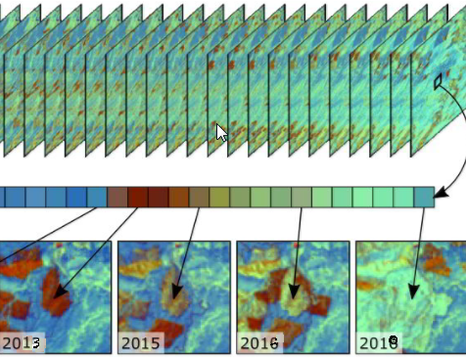

Fig 1 Image time series

**The Goal:**

Quantify the vegetation changes taking place on Cadote and Whitemud PBs in Peace River area for period since 2013

**Methodology:**

We collected 24 summer Landsat-8 images spanning from June to September averaging four image scenes per year. Now we need to transform each of these multispectral images having 8 bands into just one band(layer) for each image. This one band (layer or index) needs to be a good indicator of vegetation changes on the landscape and fairly sensitive to biomass changes. Selection of the right index is the critical part of the process and it requires exploration. For this project we opted to use NDVI (Normalized difference vegetation index ) which has been widely used for assessing long-duration vegetation changes. Generally it is considered that NDVI is the best predictor of annual production, but it is more sensitive to herbaceous vegetation.

The objective is to statistically assess if there is a monotonic upward or downward trend of NDVI variable over time. If the trend is upward it means that NDVI values *increase* and it consequently indicates that vegetation response is strong. If the trend is downward it means we have loss of vegetation.

Instead of using linear regression model, we opted to use Mann-Kendall (MK) test (Mann 1945, Kendall 1975, Gilbert 1987).  Mann-Kendall (MK) test identifies monotonic upward (downward) trend which means that the variable consistently increases (decreases) through time, but the trend may or may not be linear. The MK test can be used in place of a parametric linear regression analysis, which can be used to test if the slope of the estimated linear regression line is different from zero. The MK test is a non-parametric (distribution-free) test and it does not require the residuals from the fitted regression line be normally distributed.

In the case of Cadote and Whitemud prescribed burns we have short time span from 2013 to 2018. We may assume linear relationship between the ***time*** variable and **NDVI** variable.

For the input we have a vector of NDVI values at each pixel and **α –significance level.**

Now, we loop over each spatial pixel, which is a stack of 24 values representing 24 different images within 5 years, and calculate some outputs.

For the output we have following grids:

**R (**correlation coefficient**)**

**Slope**

**P (**significance**)**

**Other statistics \***

Trends at the 95% confidence level (*p*-value < 0.05) or higher were considered statistically significant. Nonetheless, different levels of significance (5%, 10% or 20%) could be presented. The direction of change in biomass production) was determined by analyzing the sign of the slope coefficient. So, ‘ **+ ‘**  slope means an increase and ‘ – ‘ means decrease in bio mass change.

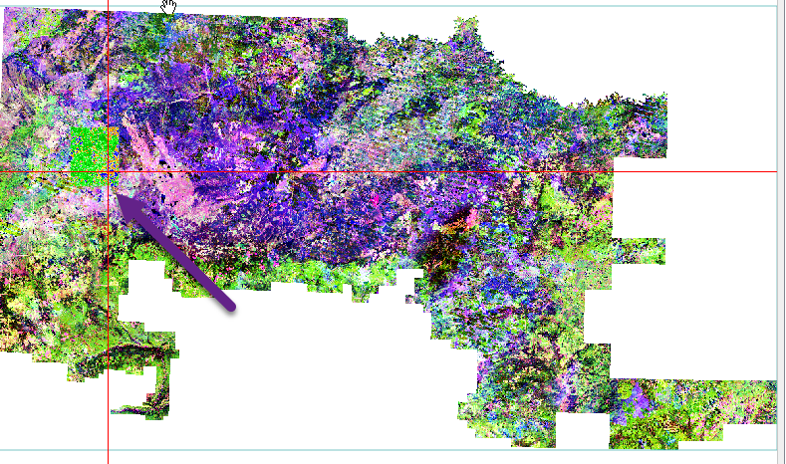 a) 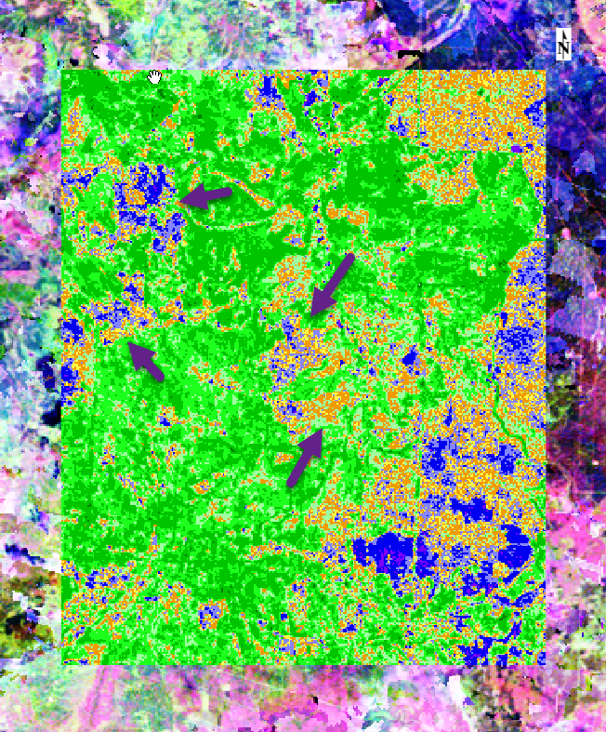 b)

Fig 3 (a,b)

3**(b)** is output **r_value**.

In an initial test, we opted to use MK test and for data we used CCRS time series of Landsat 5 data time series spanning from 1984 until 2012. We arbitrary choose an area in DP3-009-1982. The quality of imagery is really poor. For longer period like in this case, generated result is overall really good. All green color in 3b show strong regrowth on the portion of the DP3-009-1982. All brown, blue and yellow color islands (pointing arrows (3b)) have negative trend or no- trend at all meaning no significant increase in vegetation. They overlap with green islands that survived particular fire event.

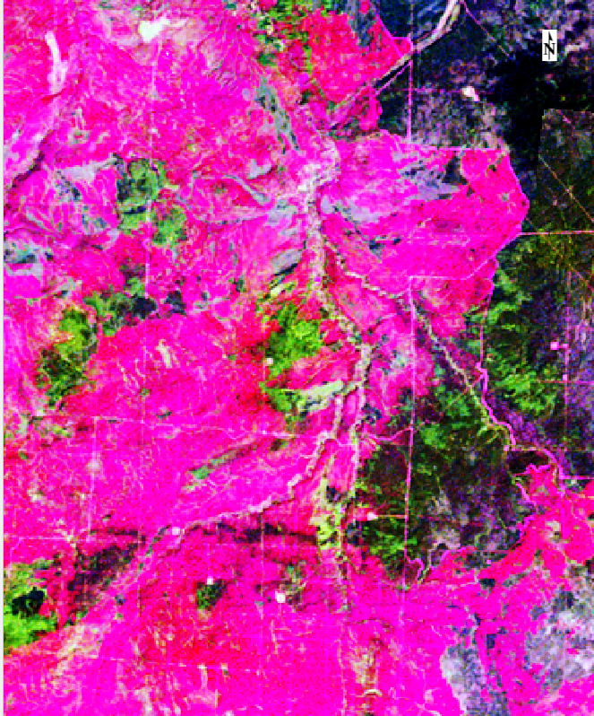 c) 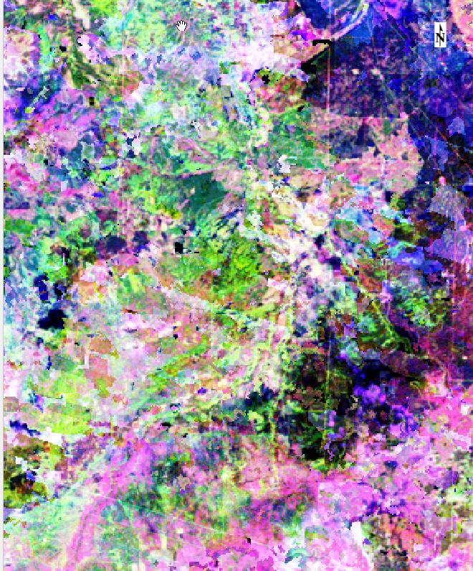 d)

Figures 3. This is *DP3-009-1982* burn from 1984 image **(c )** and from 2010 image **(d**).

The graph below (fig 4) which is a true time series shows cycles and significant upward trend. Frequency of observations is annual and this is relatively large sample to detect a trend. Below the graph there are outputs

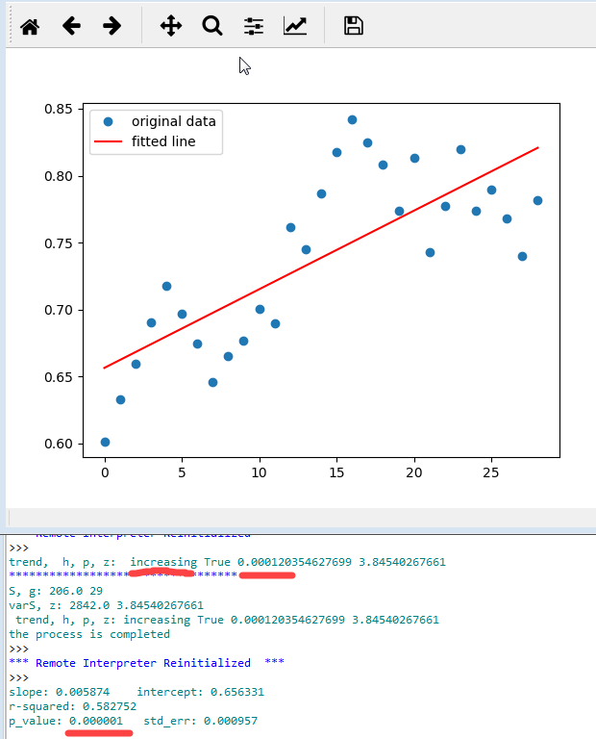

Fig 4 A pixel value from each of Landsat NDVI data spanning from 1984 until 2012

On graph below (Fig 5) we have 24 NDVI values from six years of Landsat imagery averaging 4 observations per year. A true time series require observations with a regular frequency such as monthly, daily or annually. The reason why we used 4 observation per year is that 4 values would represent too small sample to detect the trend.

Here we run MK test and linear regression to show how close the results are. Mk test for this pixel shows that NDVI trend is significantly decreasing (p = 0.039) which means there is vegetation loss since 2013 until last year. Similar result is produced by linear regression producing p_value of 0.037. The trend is statistically significant

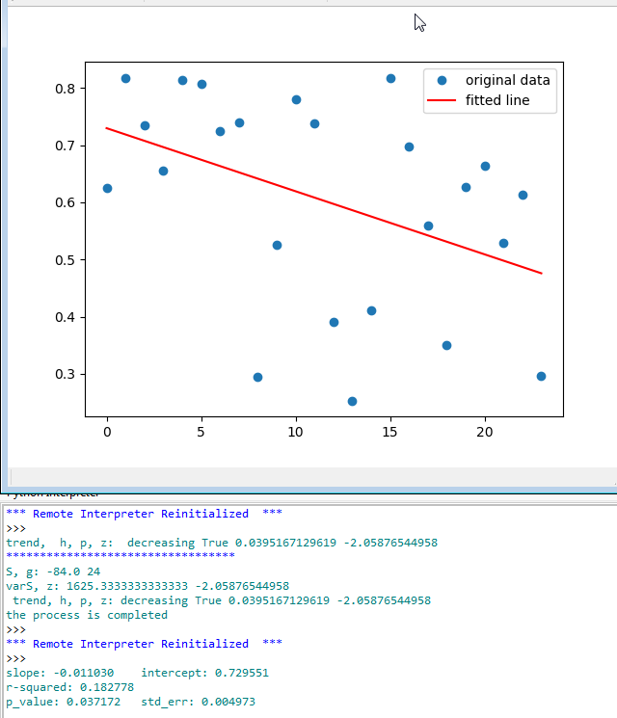

Fig 5. The points on the graph are NDVI values of one pixel for 24 images. One output is from MK test (“.trend, h, p,z”) and another from parametric linear regression at the bottom (“slope: -0.01..”). .

Here is a linear model

NDVI= α + β * Time

***α*** *is the y-intercept*, which gives NDVI values at the start of the observed period, and ***β*** *is the slope coefficien*t, which measures the rate of change of NDVI per unit of Time.

Metrics such as the slope of linear regression line and correlation coefficient and their statistical significance are then computed to assess goodness of fit and the strength and rate of vegetation changes. The outputs are in grid formats representing statistical parameters describing Linear relationship between the time and NDVI. We look at both grids where p-value is less than our significance level and r_value grid is greater than zero. If there is a significant linear relationship between the time variable and the NDVI, the slope will not equal zero. We choose to focus on **An_rval.tif** (coefficient of correlation for 24 values in a pixel) and **An_pval.tif**. The values greater than zero in **An_rval.tif** indicate areas that have positive trend and experience an increase in vegetation response. The other grid – **An_pval.tif** is being compared against significance level which we may set up as 0.05 (5%) or 0.1 (10%) or even 0.2 (20%). Wherever the ‘p’ values are less than the significance level (0.05 or 0.1 or 0.2), we cannot accept the null hypothesis of having slope linear regression equal zero. It means that trend is significant, but still it may be downward or upward.

In figures 6 and 7 , we compare output ‘r’ values for NDVI and NBR indexes. NBR index (fig 7) is showing more green and yellow colors than NDVI. The only way to find whether NDVI or NBR is closer to reality is to do ground check.

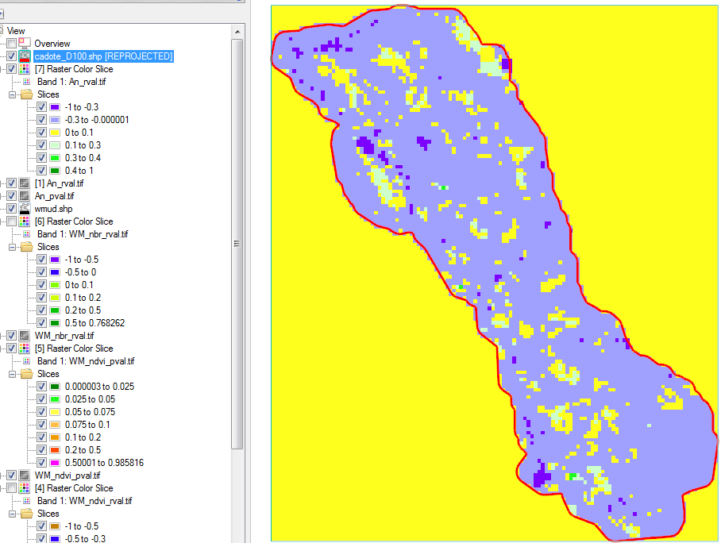

Figure 6 Cadote’s **r_value** for **NDVI index** . Yellow color indicates small changes in vegetation recovery, while greenish colors indicate a strong regrowth.

A ‘r’ value represents a strength of linear relationship and if it is positive and closer to 1, it means vegetation regrowth is increasing and it is stronger.

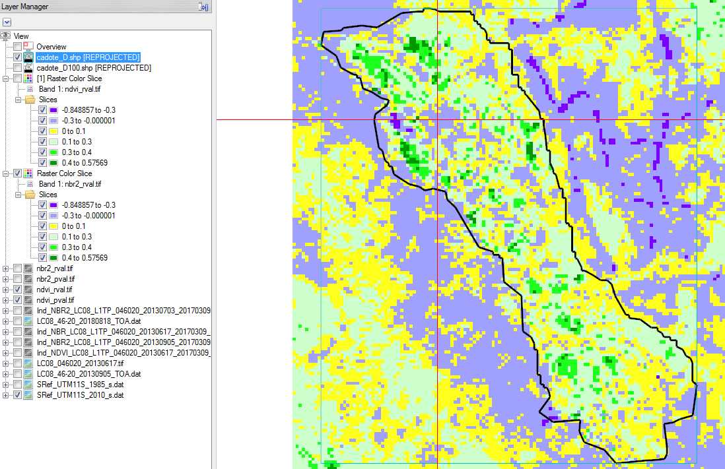

Figure 7. **Cadote’s r_value** for **NBR index**. Yellow color indicates small changes in vegetation recovery, while greenish colors indicate a strong regrowth.

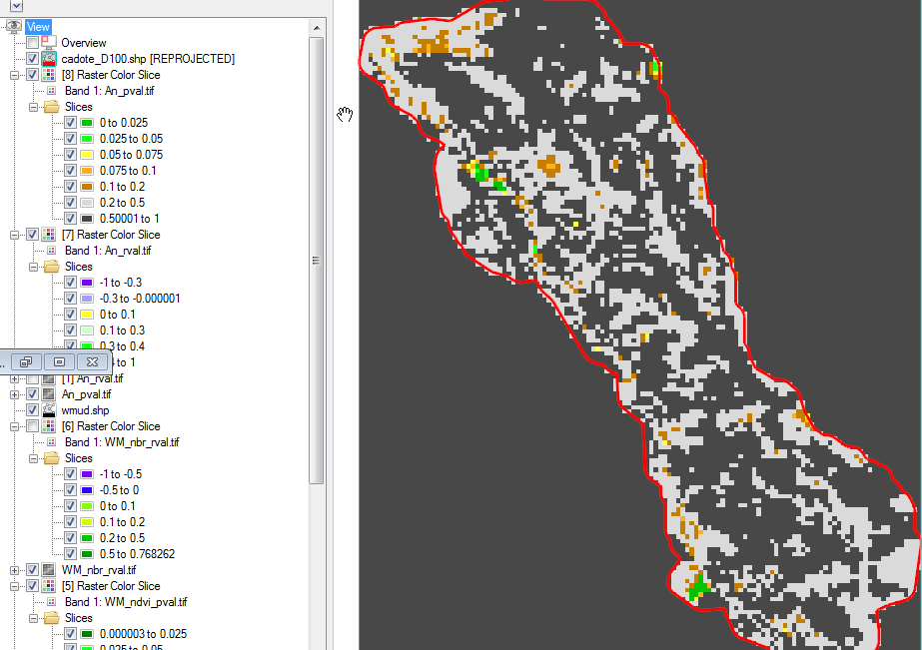

Fig 8. **p value for ndvi**. Green colors from figure 3 in combination with colors here will give you what is the significance level for increased regrowth.

From fig 8, majority of the regrowth is not statistically significant at 5% significance level.

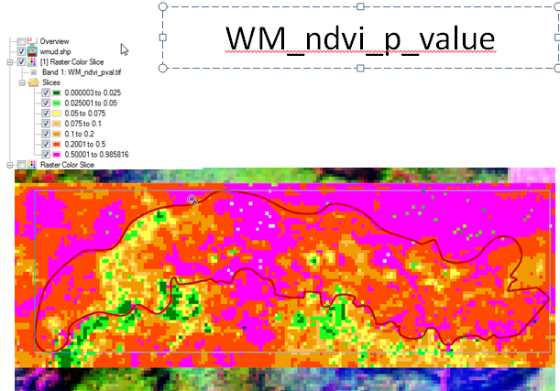

Figure 9 Whitemud’s **p_value** for NDVI index. Greensih color indicates highly significant changes either in loss of vegetation or increase of vegetation recovery.

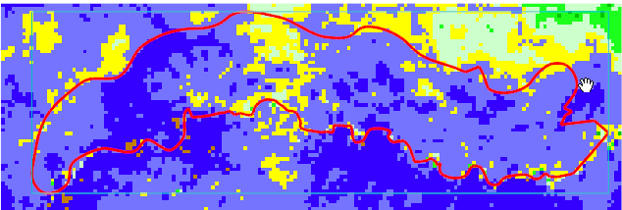 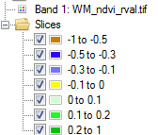

Figure 10. Whitemud’s r_value output for NDVI index. Greensih color indicates positive changes in vegetation recovery, while bluish colors indicate a non regrowth or loss of biomass with the time. When we look at these positive changes against figure 7, we conclude that they are not highly significant.

In this work we tried to iidentify the process that would test project area for significant recent NDVI trends corresponding to vegetation response or loss. This process of determining trend in vegetation regrowth has been made automatic . In the next phase, we need to go on the ground and collect some ground data and look at them against this spatial output to see how our output is represented on the ground. Also, we should explore different indices such as greenness, brightness, Vegetation Optical Depth (VOD), and others to see which of them may be more sensitive to bio mass increase on the landscape.

This process could be applied to determine potentially when we should go back to these PB sites and prescribe another round of burning. Similarly, we could run this process on historic burns and prioritize those experiencing positive trends for reinventory of forest fuels.